Remote Sensing
April 2 2003
Inez Fung

- Remote sensing system: energy source, target, atmosphere as interference or target, signal, sensor, interpreter.
- Satellites carry remote sensing instruments in an orbit around the earth.
- Resolution: spectral resolution (wavelengths sensed by instrument), radiometric resolution (sensitivity of instrument to intensity of radiation at a given wavelength), spatial resolution (pixel size), temporal resolution (frequency of measurements).
- Orbits: Satellites in a geostationary orbit (23h 56 m; 35,000 km) are at a fixed position above a point on the equator, e.g. weather satellites and some communication satellites and provide continuous spatial coverage for a sector of the Earth. Satellites in low earth orbits (LEO, <1000 km) have typical orbital periods of <100 minutes, and provide global coverage in days or weeks.
- Energy source for instrument: passive or active. Passive systems measure reflected solar spectrum (short wavelengths) or transmitted terrestrial spectrum (long wavelengths). In an active system (e.g. using lidars), the instrument emits radiation/light of a specific wavelength to a target, which reflects/scatters radiation back to instrument. Change in properties of the radiation provides information about the target or intervening atmosphere. The time for the light to travel out to target and back provides a measure of the "range" of the target.
- Each target has a unique electromagnetic spectrum. e.g. green leaves have low reflectance in the visible, and high reflectance in the near-infra-red
- Remote sensing instruments measure energy in several spectral regions (bands). The spectral regions are chosen to maximize the "spectral signal" of target given the energy source, e.g.
  - clouds have high albedos in the visible;
  - there are no greenhouse gases in the "thermal window" to absorb thermal emissions from the earth --> surface temperatures.
  - Fires are detected in several ways: smoke has high albedo and reflects light in the visible; hot spots are detected using the 3.7 mm channel (intensity of radiation is very sensitive to small changes in temperature); soot absorbs ultra-violet radiation and is detected by the measurement of UV attenuation.

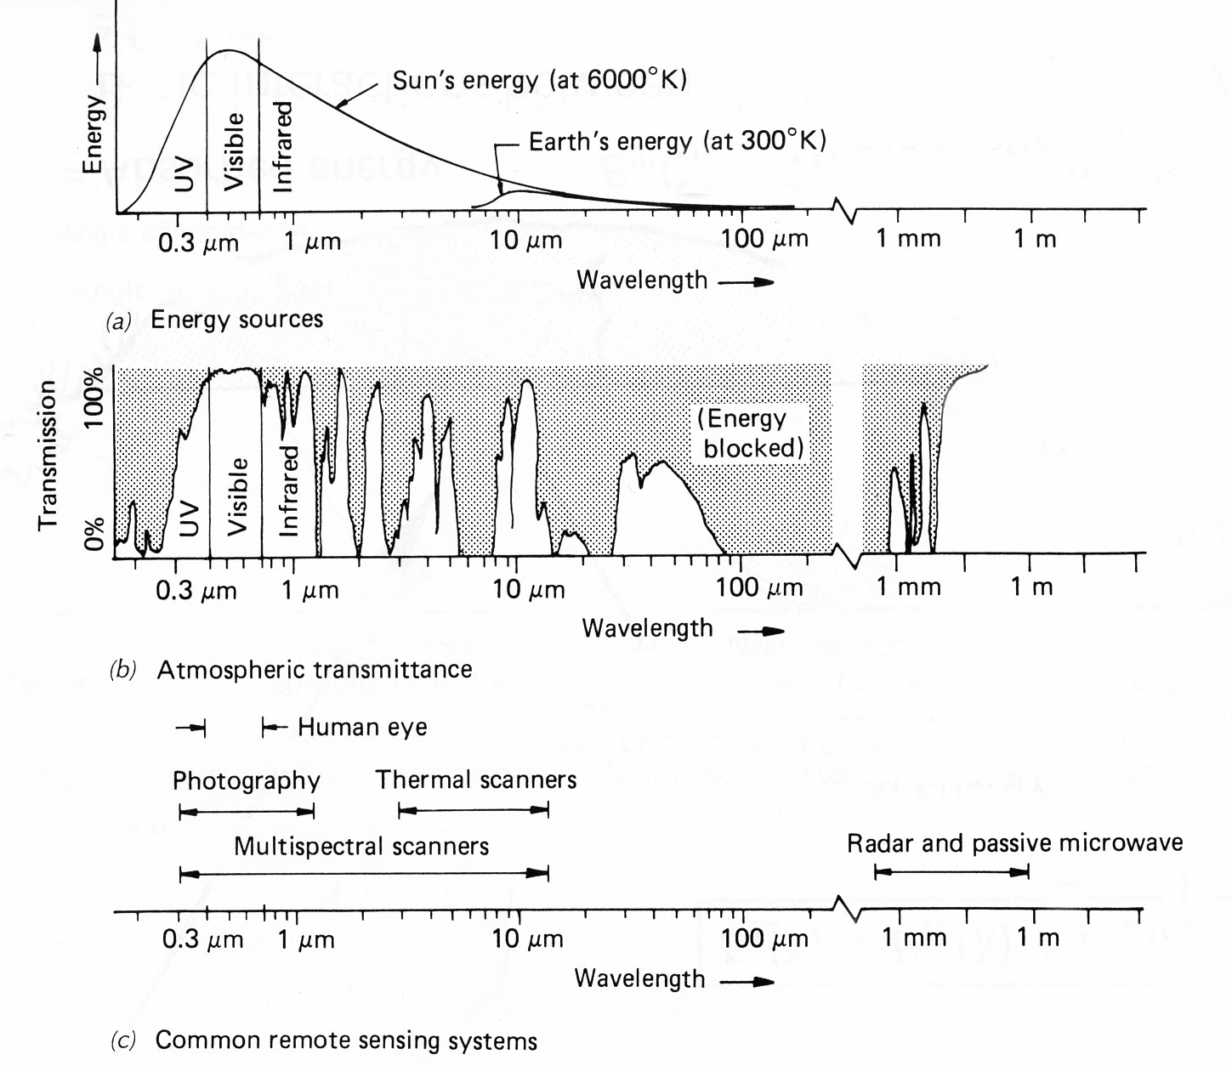
Passive Energy Sources:

